Downloading A Free Funeral Program Template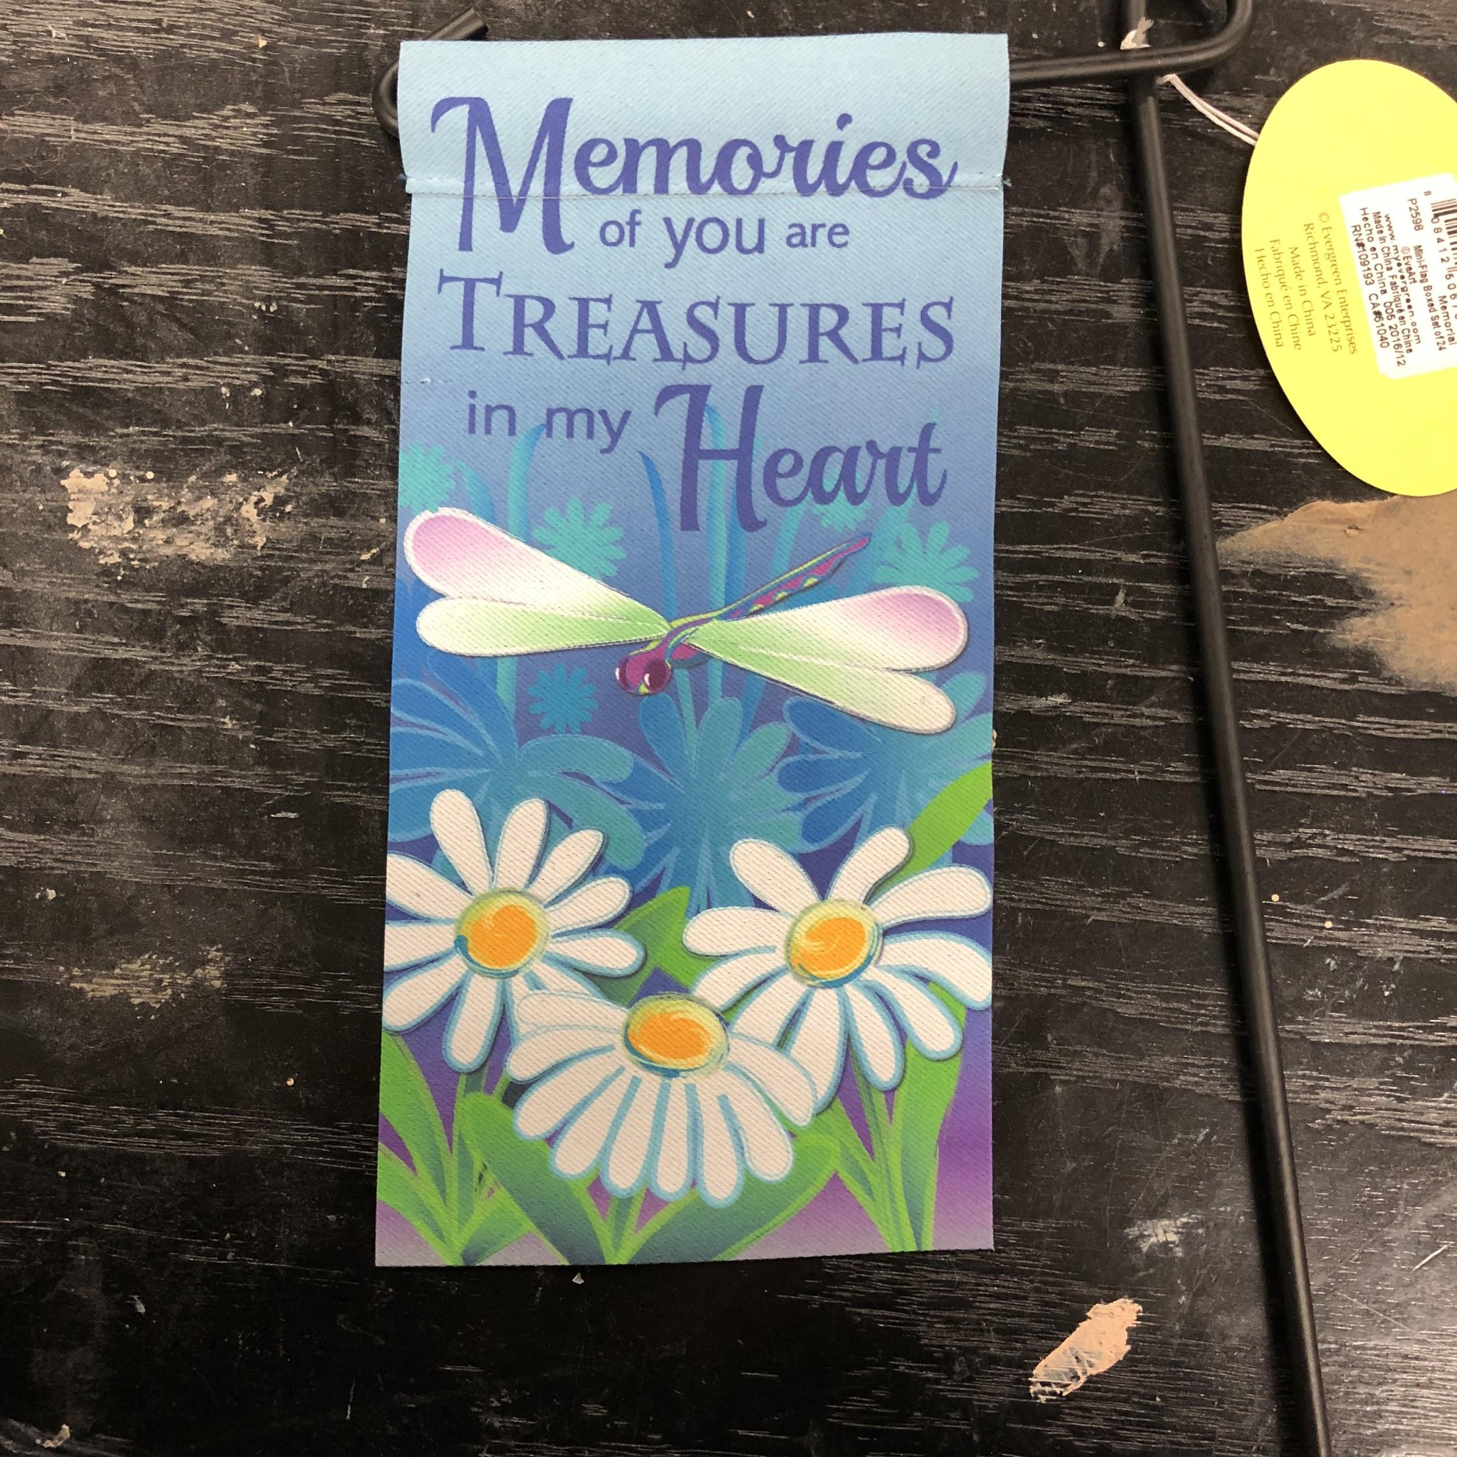

Funeral program templates pamphlets are described as a trifold since they are folded up in 3 equivalent sections or thirds on a letter, legal or tabloid paper. The finished folded dimension is extra portable and also narrower than the conventional center layer program. This is a great alternate to the bifold due to the fact that it generates an intriguing and also eye-catching presentation with its multiple layer layout.

The funeral sales brochure is a generally utilized layout that is offered in a range of dimensions. The Funeral Program Templates website supplies this collection of ready-made funeral service brochure themes which are formatted front as well as back on one sheet of paper. Including web pages to this layout is not suggested. If you require even more area, the bigger sizes are suggested. Edits in Word, Author, Apple Pages and Google Docs! This is an optimal choice for those that wish to make your very own funeral service sales brochure and print it on your own or locally.

There are predefined picture boxes are movable or detachable. Include your own clipart, decorations or the template is beautiful as is. The edge to border published with a borderless printer, or else you will certainly have a 1/8" white border around the boundary of the page. Please order our optional "personalization service" with the design Funeral Program Templates acquisition just if you need assistance putting the program with each other. Also have a look at our provided for you service if you would certainly like our all-inclusive, complete funeral pamphlets style and printing.

A funeral sales brochure (also called a funeral program or funeral program) is a printed handout that is given out during a funeral service or funeral. The brochure provides information concerning the funeral service and information about the deceased. The Funeral Program Templates brochure generally has a trifold design, which suggests that the paper folds twice providing 6 panels of info. These trifold designs can feature various paper dimensions, consisting of common 8 1/2" x11", legal size which is 8 1/2" x 14" and even a huge tabloid size which is 11" x 17".

Funeral Program Templates don't always have to be a trifold layout. Other layouts for printed funeral service stationery consist of bifold (solitary fold) which is like a funeral service pamphlet or memorial pamphlet, and also two as well as four-page finished (tabbed) layer, which folds like a booklet to expose a vibrant rectangle-shaped tab with message and funeral cards, which is a smaller variation of the solitary layer design template.

Once you have an idea of the information that you will certainly be consisting of, you might want to create the sales brochure on your own on your personal computer and also printer. The quickest as well as easiest method to create your very own funeral brochure is to purchase a funeral service sales brochure template. Themes are preformatted records that assistance you promptly create your sales brochure. Layouts are conveniently offered on the web as well as be available in a range of styles, designs and also layouts. They can typically be downloaded immediately.

Here are a couple of fast pointers to take into consideration when selecting a design Funeral Program Template:

When choosing a template style, consider your liked one's tastes, suches as and also favored points.
You can picking a design visuals based on your loved one's favored shade or flower. You can additionally select a design based upon outdoor scenery or your liked one's leisure activities or rate of interests or their religious history.

See to it you have the software required to edit your Funeral Program Template:.
Template software can be word processing program, such as Microsoft Word, Pages for Mac or OpenOffice, or it can be a desktop publishing program such as Microsoft Author. Ensure that you fit utilizing the design template software program.

Comprehend what message and also design aspects that can be transformed and also edited on the template.
This includes message, graphics, boundaries as well as various other style aspects. You may wish to transform the caption of the front, see to it you are able to do so. Various inscriptions as well as titles consist of "Home Going Service", "In Loving Remembrance" as well as "Party of Life" to among others. See our article on "Funeral service Program Titles" for more information.

Gather all the details that you intend to consist of in your layout. There are many different kinds of information that can go in a funeral service sales brochure. Right here is a tasting of the different sorts of details that can be included:

Sales Brochure Title or Inscription, such as "In Remembrance" or "Honoring her Life". You can choose a subtitle to put on the cover that mirrors the "tone" of your solution.
Cover Image-- The majority of sales brochures consist of a cover picture, or some type of image of the dead, yet it is not compulsory.
Obituary or Life Tribute-- Usually the among one of the most important elements of the program, and also can likewise be among the most difficult tasks of making your sales brochure. See our write-ups on how to compose an obituary for more details.
Funeral Service Order of Sevice or Funeral Outline-- tells the events that will happen during the ceremony or service. This can likewise be challenging to create, and frequently you will certainly require the assistance of the people who are assisting you plan your service, such as your funeral director, clergy or celebrant. See our post on Funeral Program Template to learn more.
Family members photo collections-- photo collages can help relieve mourning visitors, as well as aid turn your brochure right into a memorable keepsake. You might likewise think about including ornamental clipart to help personalize your program and also make it more certain to your loved one's tastes.
Rhymes, Scriptures and various other details-- in loving memory rhymes, prayers as well as bibles, personal notes to or regarding the dead, favored quotes or phrases can also be consisted of. See the short article "What enters a Program" for more details regarding what you may wish to consist of in your pamphlet.

When editing your layout, save your job regularly.
When printing, see to it you have sufficient ink or toner available.
Additionally make sure you enable adequate time for folding your pamphlets.

With a little effort you can create the best funeral service or memorial pamphlet to capture the memories of your loved one.

The Funeral Program Site
Address: 5080 Virginia Pkwy STE 700, McKinney, TX 75071
Phone: (800) 773-9026

OUR ONLINE PORTALS:
Funeral Program Layout
Best Poems For Funerals
Memorial Bookmarks
Funeral Program Printing
Free Funeral Program Template
DIY Templates
Funeral Program Templates
Funeral Program Template
Printed Memorials
Custom Program Covers
Make Your Own Funeral Programs
Funeral Program Paper
Funeral Paper
Funeral Bulletins
Funeral Brochures
Custom Funeral Programs
Funeral Flyers
Funeral Booklets
Funeral Program Designs
Memorial Programs
Funeral Pamphlets
Memorial Order of Service
Funeral Order of Service Programs

